Probability
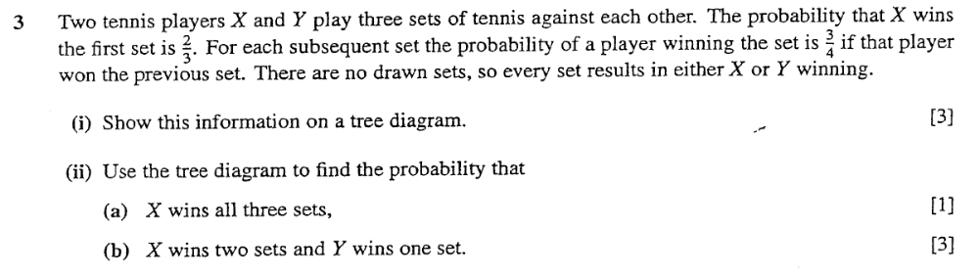
Jan03 Quesion3
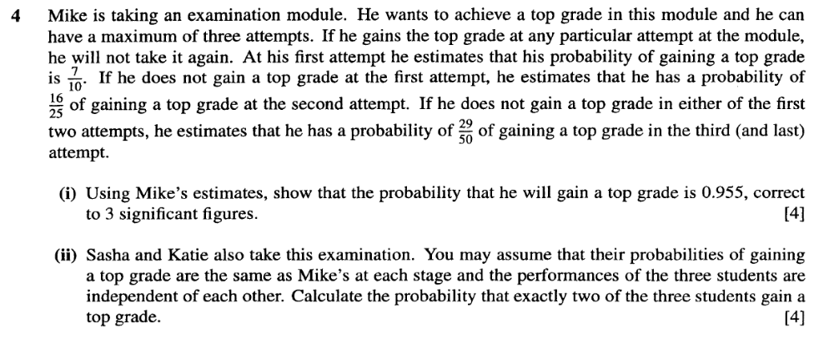
Jan04 Quesion4
Permutations & Combinations
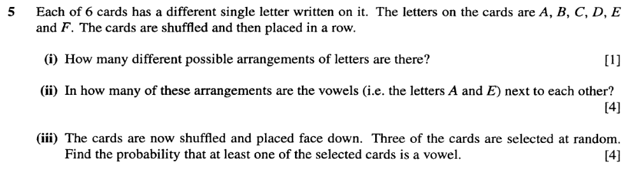
Jan04 Quesion5
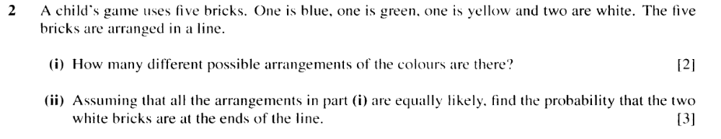
Jun04 Quesion2
Binomial & Geometric Distributions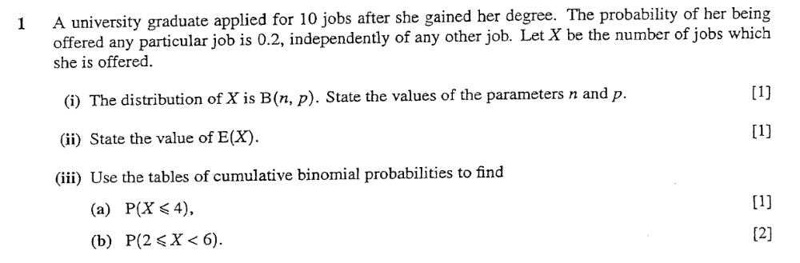
Jan03 Quesion1
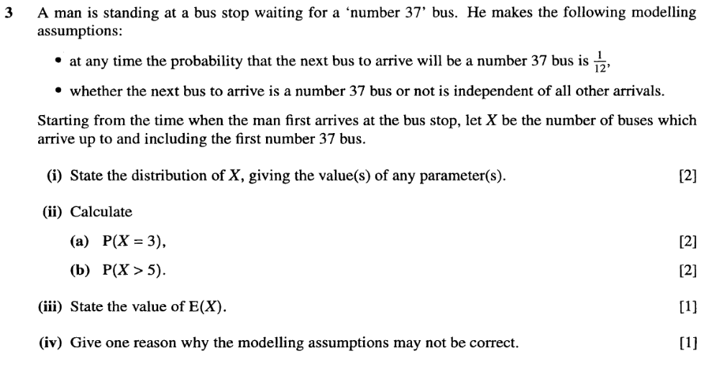
Jan04 Quesion3
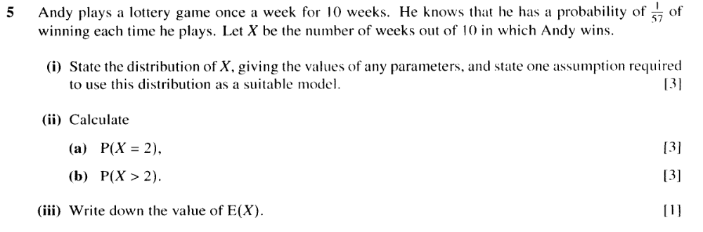
Jun04 Quesion5

Probability Distributions / Expectations Variance

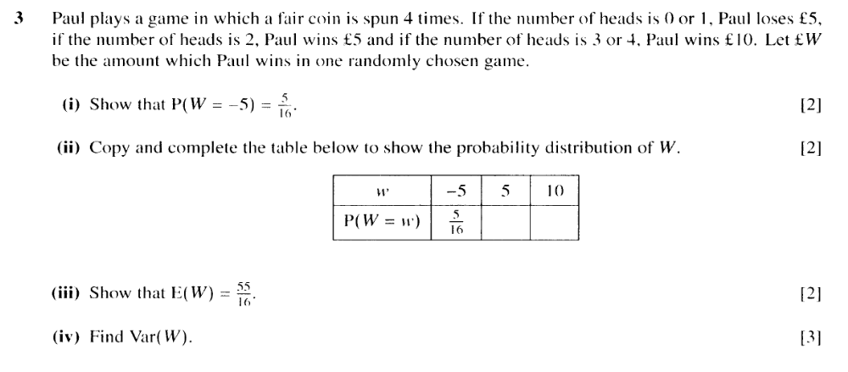
Jun04 Quesion3
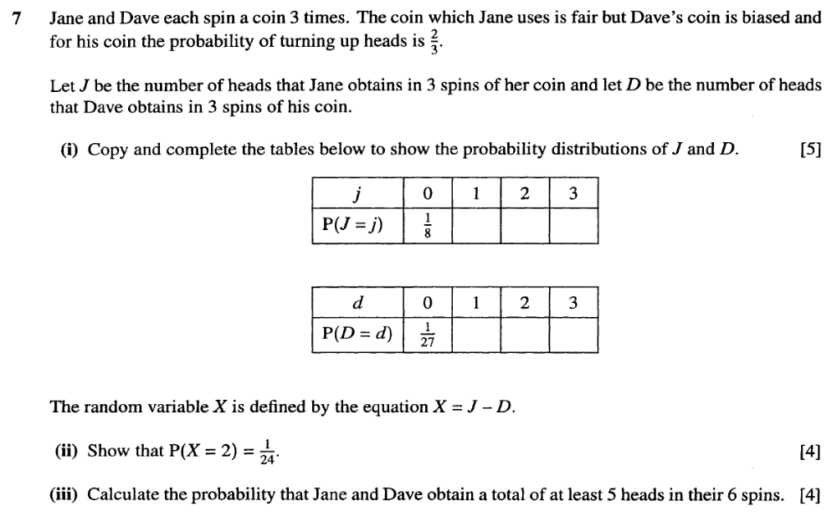
Jan04 Quesion7

